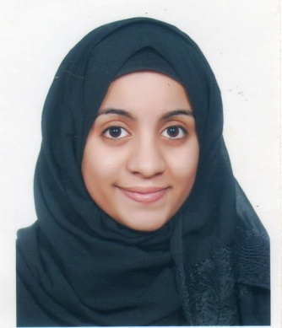

***Fatima S.Faisal S. Ali Alalawi***

Contacts: Mobile 38383204

[alsayda.1991@hotmail.com](mailto:fatimaalalawi91@hotmail.com)

House 965, Road 428, Sanabis 404

Kingdom of Bahrain

**Personal Details:**

Profile : Female

Nationality : Bahraini

Date of Birth : 3, Aug, 1991

CPR : 910804257

**Career Objective:**

Any position in your honorable company ,where I can demonstrate my communication skill.

**Educational Qualification:**

**Jan 2010 – May 2015**  AMA (Bachelor in Business Informatics)

**Sep 2006 _ June 2009** Al-Hoora Commercial Secondary Girls School (Commercial)

**Experience:**

**April 2017 _June 2017 Aptech Institute**

Computer Teacher and Receptionist .

**May 2016 _August 2016 Curve Jewelry** (Al Aali Mall )

Sales and Receptionist.

**Jan 2015 _April 2015 SJM** Electromechanical Engineering bureau

Receptionist and Secretary.

**Sep 2013 _April 2014 Solidarity General Takaful**

Receptionist, Operator and accident and Claim Department – Main Office (Seef Tower) and Hamala Branch.

**Dec, 2011 - Sep, 2012** Easy Process Company (Proker of Loans and Insurance)

* Tele Sales
* Receptionist

Responsibilities (but not limited to):

1. Calculate the Loan.
2. Calculate the Insurance.
3. Helps in resolving work-related problems.
4. Maintains routine correspondence & draft appropriate response.

**Professional Courses**

* Emergency Medical Responder
* Primary Care
* Secondary Care
* Basic Life Support and AED
* O2 Therapy
* Vital Signs Courses

(for Human Life Organization)

* International Computer Driving License (ICDL Course training)

From [Aptech Computer Education](http://www.google.com.bh/url?url=http://www.aptechbahrain.com/&rct=j&frm=1&q=&esrc=s&sa=U&ved=0ahUKEwiJqNDL6rHTAhXFIMAKHSCSCMAQFggTMAA&usg=AFQjCNGiNuJ_toPbGQR2EE6JfwJUb7etqg).

* General English course

From British Council.

**Additional Skills:**

* Fluent in Spoken & written Arabic and English.
* Analytical and problem solving skills.
* Team building.
* Decision making skills.
* Stress management skills.

**Knowledge:**

* Using Ms Access, MS Word, MS Project, MS Excel, MS Visio and MS Power Point, Adobe Photoshop.
* Office Administration.

**Hobbies & Activities**

* Travelling
* Reading
* Browsing in Internet

**Human Resources:**

*Dear Sir..*

*I would like to express my desire to join your fins institution and give chance to participate in its prosperity and growth as member of its workforce.*

*My desire to join your organization motivated by the fine reputation and high standard of practice that you have achieved. My Curriculum vita enclosed for your reference and I would be pleased to discuss any information with you in more reference and an interview. In the meantime, please do not hesitate to contact me further information.*

*I am looking forward to hear from you with a positive consideration.*